TREND PREDICTION OF DETECTED LIGHTNING WHISTLER USING DBSCAN

I Putu Agung Bayupati¹, Ketut Adi Purnawan²
Information Technology Department, Faculty of Engineering, Udayana University
Bali, IndonesiaCenter Address Here
bayupati@it.unud.ac.id

Abstract

As a deepest part of magnetosphere, plasmasphere is a very important role in the survival of world life. This is because the plasmasphere contains the coldest plasma (coldest plasma). Electrons in this plasma move along the Earth's magnetic field lines in donut shaped which is a protective layer for the Earth. This layer has a great role to protect us from huge storm from space. This phenomenon dug into many researchers in the world to explore the Earth's plasmasphere by observing the existence of lightning whistler. By knowing the performance and existence of lightning whistler we can analyzes the level of electron density within the plasmasphere where it is an indicator of storms from space. In this observation, the researchers tried detecting the presence of lightning whistler that occurs 44 times per second. Until now we have ten years data of lightning whistler. In connection with a long data series, we need to understand what kind of knowledge within phenomenon of lightning whistler. Therefore, the system needs to develop in order to scrutinize the problem easier. Previous research, lightning whistler data have been detected successfully. Furthermore, we try to predict the detected lightning whistler whether the trend is increasing or decreasing.

Keywords- lightning whistler; DBSCAN; magnetosphere; plasmasphere

I. Introduction

Nowadays, many phenomena occur above our atmosphere. One of them is at plasmasphere. In order to observe plasmasphere preparing much data of Earth's geomagnetic are necessary [1]. Many researches have been done to understand the phenomenon of our Earth's geomagnetic that until now need dig into more in details. The Earth geomagnetic is very useful for humankind to protect us from dangerous radiations come from cosmic ray and solar storm.

Research on plasmasphere where is the part of inner magnetosphere observed in order to understand electron density that can be used to demonstrate plasmasphere model. Distribution of electron density comes from lightning whistler existences. The existences of lightning whistlers not only a good parameter to demonstrate plasmasphere but they are useful to know the phenomena in the magnetosphere.

Lightning whistler is a phenomenon that is many whistling sound come from the sky and propagate in Earth magnetic line that occurred many times during a second. Many space agencies involved mining the lightning whistler data for ten years for example NASA, Euro Space, JAXA. The problems are how to detect lightning whistler "sound" in the series long data. Fortunately, there are some researches have completed to detect the "sound" automatically. They can show the detected sound of lightning whistler shown in spectrogram. But, the next step is how to detect the trend of detected data where distributed sporadically in long data series. For example, the Akebono satellite (EXOS-D) has 23 years data series lightning whistler [2].

II. Literature Review

A. Magnetosphere and Plasmasphere
Magnetosphere is an area dominated by effect of geomagnetic. The sphere protects our Earth from solar storm so that our live are capable of existing. Plasmasphere located between inner magnetosphere and outer ionosphere that dynamically the shape is influenced by magnetosphere and ionosphere field. This area consists cold plasma (electron and proton) with high concentration ~10 - 104 electrons cm-3.

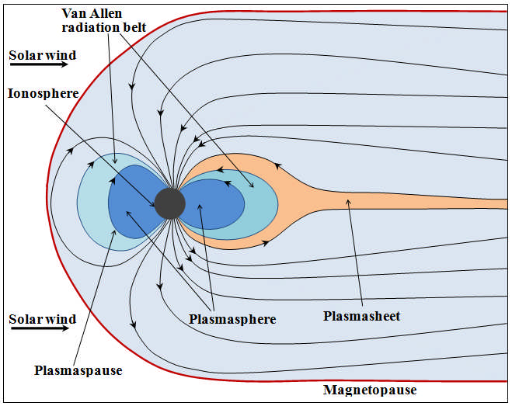

Fig 1. Illustration of magnetosphere and plasmasphere

The plasma surround our Earth and become larger near equator where is the distance is around ~2-7 Earth radii from the Earth's inner core. The shape and size are influenced by geomagnetic activities. The empiric model come from Carpenter and Anderson shows the plasma shrink too fast when geomagnetic activities are increasing and back becoming larger when no activity [3]. One of triggers indicates the activities increase is solar storm. The lightning whistler propagates in the plasmasphere and as a main indicator in order to determine the electron density to represent the solar activity.

B. Lightning Whistlers

Between plasmasphere and the Earth there are waves that contain a lot of energy propagates too fast. The waves penetrate ionosphere and propagates within magnetosphere as shown in Fig.2. They are appearing because of lightning strike that well known as lightning whistler. The researcher estimated the lightning whistler occurs 44 times in each second. The lightning could be a trigger for arising the spectrum of electromagnetic wave that can be detected using satellite or terrestrial way. In the plamasphere, the lightnings change into whistling tone in very low frequency (VLF) so that called whistler [4].

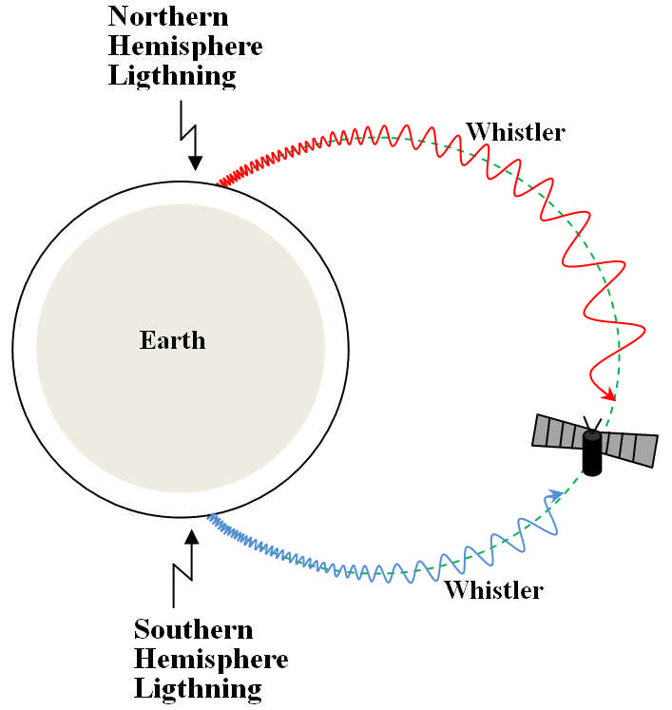

Fig 2. Illustration of Lightning Whistler

C. DBSCAN

DBSCAN (Density-Based Spatial Clustering of Applications with Noise) is an algorithm used to form the areas that have high density become clusters and form in unparticular order within spatial database that the noises are existing. Cluster in DBSCAN is complete set of connected nodes (density-connected). The nodes are not in connection with the clusters considered as a noise. Theoretically, each cluster has certain radius and at least it has a minimum number in order to categorize as a cluster. DBSCAN has own way to determine number of cluster. For that, two inputs are necessary. They are MinPits represents minimum items in a cluster and Eps () is distance among items in order to form neighborhood. neighborhood located within radius () called -neighborhood. If neighborhood agree with number of minimum data (MinPts), the object is a core object. Neighborhood comes from borderpoints consist of few items than corepoint's neighborhood. A borderpoint could be in associated within more than 1 core object. The following figure show the border point and core point using MinPts = 6 dan Eps = 1 [5].

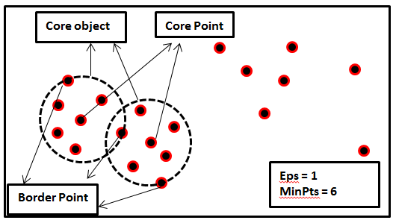

Fig 3. Illustration of Core and Border

III. Solution and Result

A. Overview of the developed system
The developed system need two inputs such as Eps(Epsilon) or radius to determine a cluster and Minpits is a number minimum nodes in order to form a cluster. They are needed to run DBSCAN process.

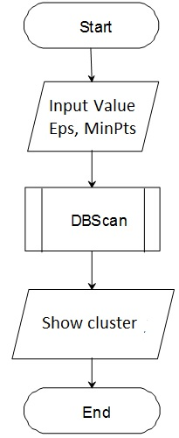

Fig 4. Schematic of developed system

The stored nodes in database are used to calculate the distance among nodes. If the distance among them less than Eps value so the nodes clustered as a region or similar region. If the numbers of nodes are located in similar region and the value is more than MinPts so region will as a cluster. In case, Euclidean Distance is utilized to calculate distance among nodes.

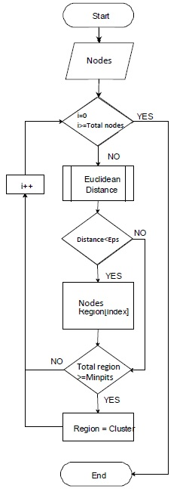

Fig 5. Schematic of DBSCAN calculation

B. System testing
Fig. 6 shows form to input the values of Eps and MinPts that needed in DBSCAN process.

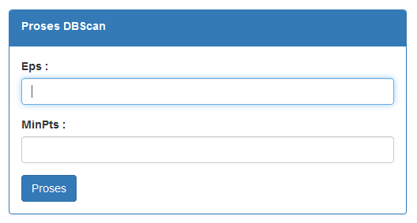

Fig 6. Form DBSCAN process

After processing, well clustered data are stored in database as shown in Fig 7. x_point and y_point are coordinate of nodes and cluster_num is title of the clustered nodes.

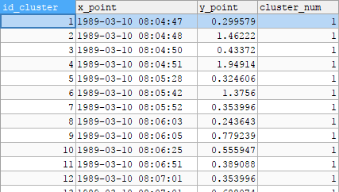

Fig 7. Clustering result

Fig 8. shows the clustering process can calculate duration between two dates. The condition needed in order to limit running data for clustering.

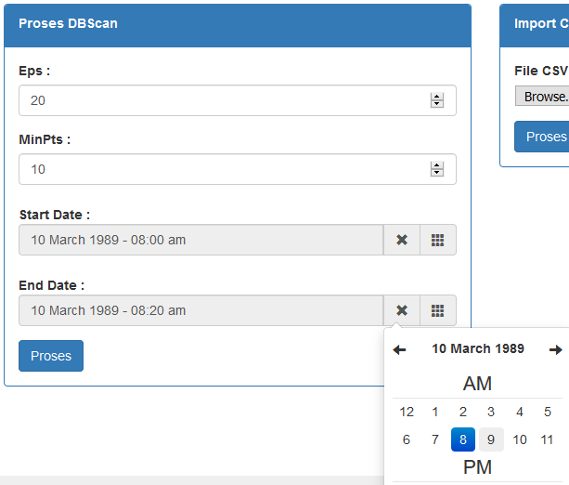

Fig 8. Determine the duration between two dates

In Fig. 9 shows short term detected lightning whistler in the date was 1998/01/24 in between times 02:29:53.578 - 03:50:25.031. In Fig. 10 the system is able to cluster the nodes automatically and shows the trend is increasing as shown the yellow nodes.

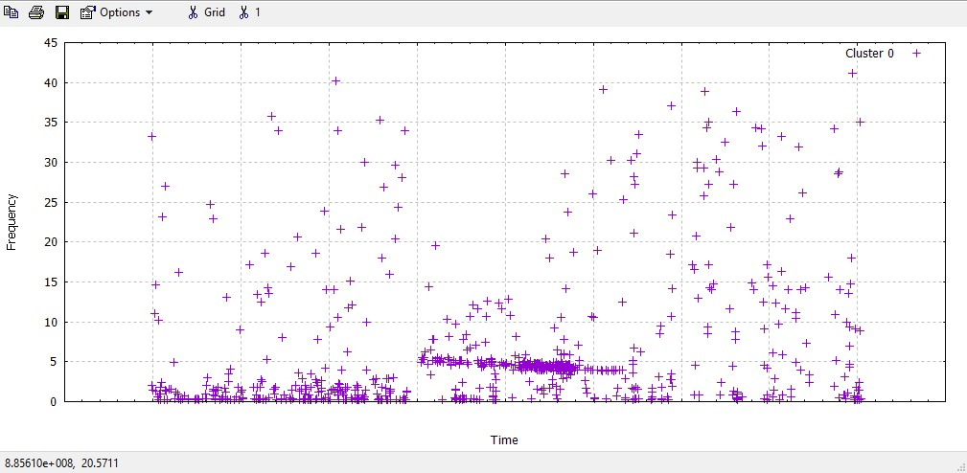

Fig 9. Detected lightning whistler nodes

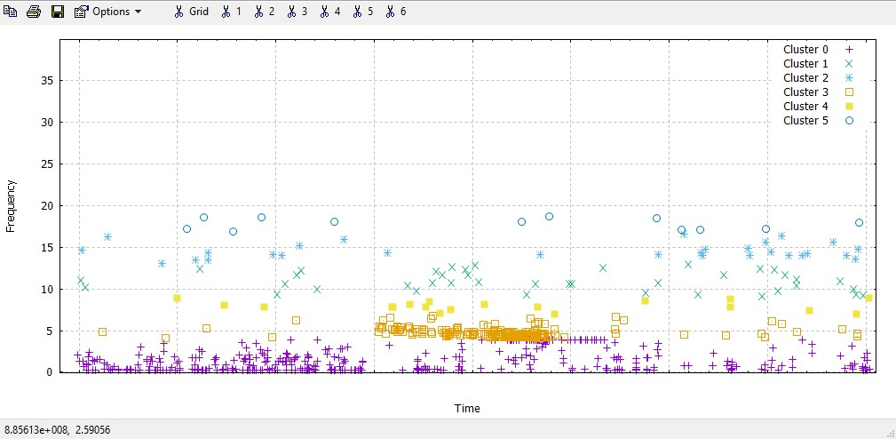

Fig 10. Clustering nodes

IV. Conclusion

The developed system by using DBSCAN algorithm has been successful to detect the short term data of detected lightning whistler that have a trend. It is very important to try in long term data.

Acknowledgment

I wish to express deep appreciation to Communication and Information Engineering Laboratory, Kanazawa University-JAPAN in preparing the Akebono lightning whistler database.

References

[1] Lichtenberger, J., F. Csaba, H. Dániel, S. Péter, R. Craig, C. Mark, C. Andrew, 2011, Automatic retrieval of plasmaspheric electron densities: first results from Automatic Whistler Detector and Analyzer Network, IEEE
- Goto, Y., Y. Kasahara, and T. Sato, Determination of plasmaspheric electron density profile by stochastic approach, Radio Science, vol.38, no.3, 1060, doi:10.1029/2002RS002603, June 2003
- Spasojević, M., J. Goldstein, D. L. Carpenter, U. S. Inan, B. R. Sandel, M. B. Moldwin, and B. W. Reinisch, Global response of the plasmasphere to a geomagnetic disturbance, Journal of Geophysical Research, 108, NO. A9, 1-14, 2003
- Chum, J., F. Jirick, O. Santolik, M. Parrot, G. Diendorfer, and J. Fisr, Assigning the causative lightning to the whistlers observed on satellites, Annales Geophysical, 24, 2921-2929, 2006
- Martin Ester, Hans-Peter, Jorg Sander, Xiaowei Xu, “A Density-Based Algorithm for Discovering Clusters in Large Spatial Databases with Noise”, Institute for Computer Science, University of Munich, KDD-96 Proceedings, 1996

